**Referral Contacts**

Use this doc to contact a person for referral or guidance of a test/interview .

These are successful students of Kumar K and they will help you with referral -> only if you are also a KumarK student.

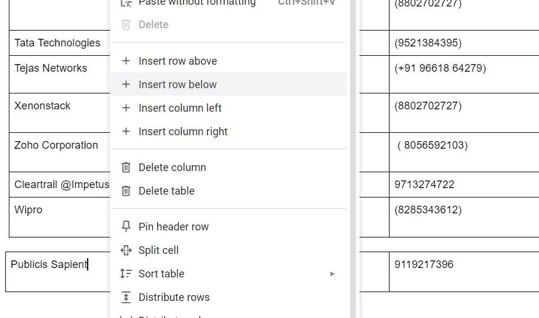

| **Company Name** | **Have Experience of interview/offer/referral/online test of the company** | **Contact No/**  **Phone Number.** |  |  |
| --- | --- | --- | --- | --- |
| **Hyland** | **Amit** |  |  |  |
| **GE HealthCare** | **Masthan** | **+91 6303 191 318** |  |  |
| **CronJ** | **Navneet** | **+91 94605 61180** |  |  |
| **Apisero** | **Sai Bhaskar** |  |  |  |
| **Salesforce** | **Nilesh** |  |  |  |
| **Jupiter Networks.** |  | **+91 77580 85416** |  |  |
| **AirBnB** | **Dev** | **+91 99241 32070** |  |  |
| **Atlassian** | **Salman (SDE-2)** | **Contact KumarK** |  |  |
| **Axis** | **Romit Choudhary** | **+91 96606 70226** |  |  |
| **Solera** | **Meghana** | **+91 6303 871 730** |  |  |
| **TD Bank** | **Henish Patel(4Lac/month Internship)** | **+1 (226) 202-0398** |  |  |
| **CDOT** | **Ishaan** | **+91 6206 623 309** |  |  |
| **Barclays** | **Jalaj** | **+91 80093 08481** |  |  |
| **OpenText** | **Rineeth** | **+91 96299 64444** |  |  |
| **Optum** | **Karthik** | **Contact KumarK** |  |  |
| **Microsoft** | **Ritik Raj** | **Contact KumarK** |  |  |
| **Nutanix** | **Parinitha** | **+91 94483 67925** |  |  |
| **JP Morgan** | **Deepthi** | **Contact KumarK** |  |  |
| **Barclays** | **Sanket** | **+91 91722 40875** |  |  |
| **Samsung** | **Talha**  **Vijay** | **Contact KumarK**  **+91 98948 92715** |  |  |
| **Siemens** |  | **9521394808** |  |  |
| **Microchip** | **Varda** |  |  |  |
| **CGI** | **Manish** | **+91 73620 66681** |  |  |
| **HSBC** | **Shivam** | **Contact KumarK** |  |  |
| **Accolite** | **Ruhani** | **+91 81602 32711** |  |  |
| **ZS** |  |  |  |  |
| **Ribbon** | **Vipin** | **Contact KumarK** |  |  |
| **InfoEdge** | **Aditya Sharma** | **Contact KumarK** |  |  |
| **SchneiderElectric** | **Tushar Singh** | **+91 82879 74682** |  |  |
| **IQVIA** | **Shubham** | **+91 96241 64015** |  |  |
| Morgan Stanley | Sneha | +918420736761 |  |  |
| RazorPay | Rohan | +91 93808 29304 |  |  |
| Adobe | Kritika | +91 88169 02750 |  |  |
| Salesforce | Nishant | +91 91218 67608 |  |  |
| Nokia | Mayank Gupta | +91 84149 21720 |  |  |
| Dell | Auroshis Ray | +91 79786 70720 |  |  |
|  |  |  |  |  |
| Juspay | Prasanth N  Kashish  <https://leetcode.com/discuss/interview-question/3109485/JUSPAY-or-BANGLORE-or-Internshiporinterview-Experience> | +91 6363 331 787  +91 89500 10348 |  |  |
| Microsoft | Sarang | +91 70306 53264 |  |  |
| ZoomCar | Vipin |  |  |  |
| GoldMan Sachs | Oshi Jain | Karan | Contact KumarK |  |  |
| Persistent Systems | Kuldeep Singh  Shreyas | +91 93152 38538  +91 80878 00420 |  |  |
| Airtel | Sushant | (+919158417553) |  |  |
| Amazon | Kumar K  Sanjana  Aayushi Jain(Intern)  Saloni (Intern) | (8879355057)  (+1(443)850-6176)  +91 98975 28700  +91 99606 33207 |  |  |
| American Express | Ayan | (+91 79881 73038) |  |  |
| Caterpillar | Vivek | (+91 81799 86536) |  |  |
| Dragon and Fly | Sourav Borate | +91 76667 24147 |  |  |
| Adda 24x7 | Osho | (+91 70079 77235) |  |  |
| Accenture-ASE | Pankaj Goswami  Vaibhav Tripathi | (8285343612)  (6267997773) |  |  |
| AbinBev GCC | Saurabh Jejurkar | (9370891219) |  |  |
| Afour technologies | Mahesh | (+91 97650 40510) |  |  |
| Barclays | Rohan | (+91 77208 02711) |  |  |
| Cisco | Sri Raj Milani | (+91 81448 97438) |  |  |
| Cognizant | Marma K Chowdhury  Kumar Rounak  Sourya Shome  Arunima Das  Shantanu Sahay (6.75)  Yash Goyal  Akansha Saxena  Ritam Ganguli  Pankaj Goswami  Harshvardhan | (8240312013)  (9875551247)  (7980654823)  (9836148788)  (9304587976)  (7351314778)  (8368691888)  (7000522673)  (8285343612)  (8100854915) |  |  |
| Capgemini | Naveen Gokavarapu  Shrey Bhandari  Pankaj Goswami | (7995336737)  (9414981811)  (8285343612) |  |  |
| Uptycs | Saurabh Jejurkar | (9370891219) |  |  |
| EPAM System | Saurabh Jejurkar | (9370891219) |  |  |
| Hexaware | Sarim Ahmed | (8582883122) |  |  |
| Hashedin by Deloitte | Bhargav Thota | (8309473880) |  |  |
| Infosys | MarmaKChowdhury  Saumi Patel  Daisy Sharma  Aman Verma  Shantanu Sahay(DSE)  Pankaj Goswami  Aman Khan | (8240312013)  (8299202057)  (9079204749)  (7275000411)  (9304587976)  (8285343612)  (7898622624) |  |  |
| IBM | Aditya Chauhan(Cyber Security) | (9045447759) |  |  |
| IBS Software | Harshvardhan | (8100854915) |  |  |
| JIO | Saumil Patel  Sushant | (8299202057)  (+91 91584 17553) |  |  |
| Light and Wonder | Trisha Chatterjee  Bibhu Prasad Saha | (8777271695)  (+91 8731901130) |  |  |
| NEC | Saumil Patel | (8299202057) |  |  |
| NinjaCart | Deo | (+91 88099 43660) |  |  |
| Nagarro | Aman Verma | (9559474980) |  |  |
| Oracle | Yuvraj  Apoorva  Akash  Avinash - Devops - Associate Application Dev | (+91 70096 54140)  30LPA student will join in july.  (+91 98189 37631)  (+91 98661 84101 ) |  |  |
| PaYTm | Aditya Gupta | (+91 98114 18102) |  |  |
| Quolom | Md Mubeen | (+91 70970 08749) |  |  |
| RedHat | Aayush | ( +91 87083 73368 ) |  |  |
| Reya Health Onsite Teams | Tarun Singh | (6306397166) |  |  |
| Sprinklr | Sujay Ambekar | (8217733584) |  |  |
| Supermind | Saurabh Jejurkar | (9370891219) |  |  |
| simplifyVMS | Utkarsh Vashisht | (8287303376) |  |  |
| TCS | Saumil Patel  Aman Verma  Sanchari Ghosh  Aditya Bharat  Pankaj Goswami  Priyanshu  Ankit Singh (TCS codevita)  Harshvardhan  Vinay(digital)  Shyamal Prajapati | (8299202057)  (7275000411)  (8583862394)  (9419222425)  (8285343612)  (8802702727)  (8100854915)  (6302634182)  (9426186265) |  |  |
| Tata Technologies | Ravi Anand | (9521384395) |  |  |
| Tejas Networks | Rishikesh | (+91 96618 64279) |  |  |
| Xenonstack | Priyanshu | (8802702727) |  |  |
| Qualcomm |  | +91 70428 01667 |  |  |
| Cleartrail @Impetus | Vikas Sen | 9713274722 |  |  |
| Wipro | Pankaj Goswami | (8285343612) |  |  |

<https://ideone.com/RFaabM>

<https://ideone.com/DozoEh>

<https://ideone.com/sbFoKH>

<https://ideone.com/OE5TO2>

<https://ideone.com/Fc0Nu6>

<https://ideone.com/ox7lek>